- 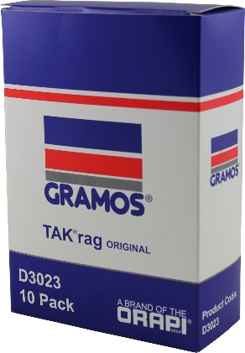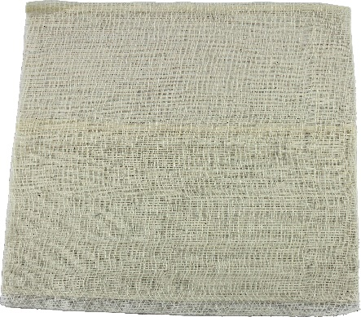

Woven Cotton TAK®rags

- 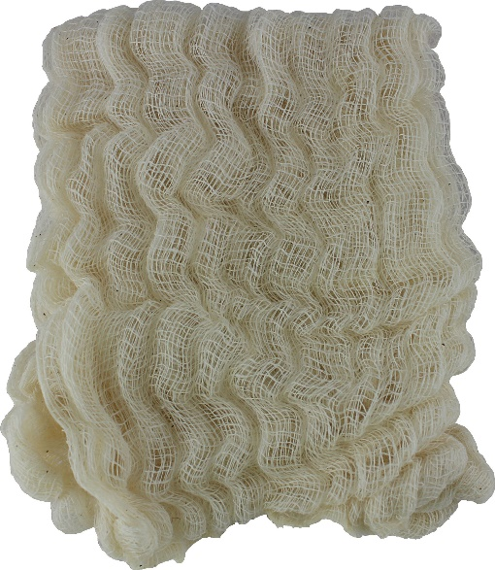

Woven Cotton TAK®rags
maxaTAK®

- 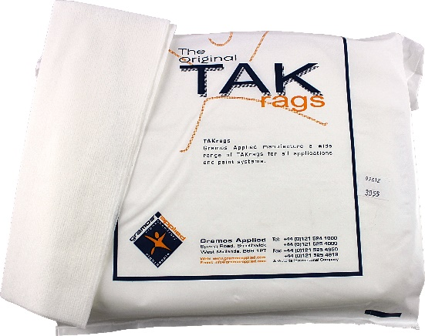

Non Woven TAK®rags
Ultra TAK®

- 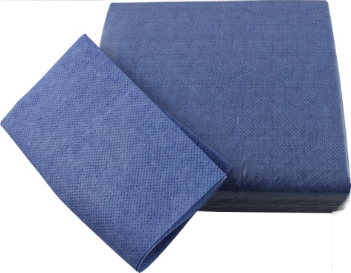

Woven Cotton TAK®rags
aquaTAK®

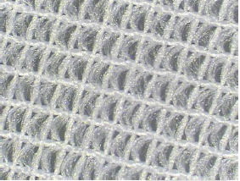
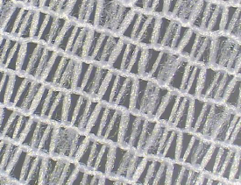
- 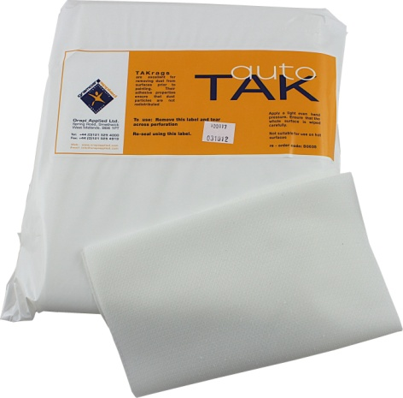

Knitted Polyester TAK®rags
autoTAK®
Continuous Filament Knitted Polyester

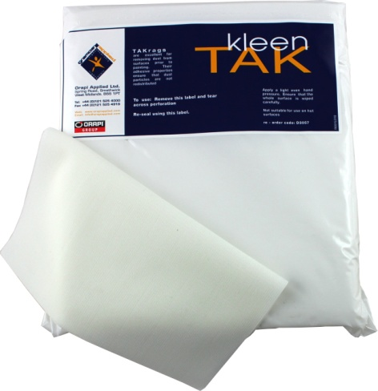

Knitted Polyester TAK®rags
KleenTAK®

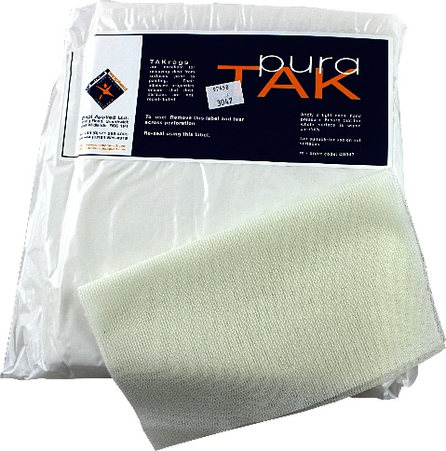

Knitted Polyester TAK®rags
puraTAK®

